|  |  |
| --- | --- |
|  | Faculty of Information Science and Technology  Universiti Kebangsaan Malaysia  43600 Bangi Selangor |
| **TTTK2103**  **Computer Network Technology** | |

**PACKET TRACER**

4.7.2 Packet Tracer – Connect the Physical Layer

|  |  |
| --- | --- |
| **Name** | **Matrix Number** |
| Mariam binti Masuan | A182976 |
| Mohamad Saiful Nizam bin Abd Aziz | A179830 |

## Part 1: Identify Physical Characteristics of Internetworking Devices

### Identify the management ports of a Cisco router.

a. Click the **East** router. The **Physical** tab should be active.

b. Zoom in and expand the window to see the entire router.

Which management ports are available?

Answer: AUX and Console ports

### Identify the LAN and WAN interfaces of a Cisco router.

a. Which LAN and WAN interfaces are available on the **East** router and how many are there?

Answer: 2 WAN interfaces and 2 Gigabit Ethernet interfaces.

b. How many physical interfaces are listed?

Answer: 4 interfaces

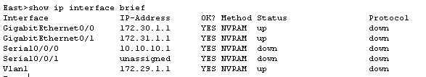

c. Enter the following commands:

**East> show interface gigabitethernet 0/0**

What is the default bandwidth of this interface?

Answer: 1000000 Kbit

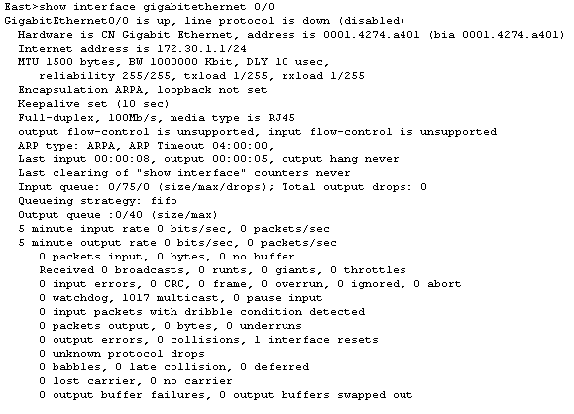

**East> show interface serial 0/0/0**

What is the default bandwidth of this interface?

Answer: 1544 Kbit

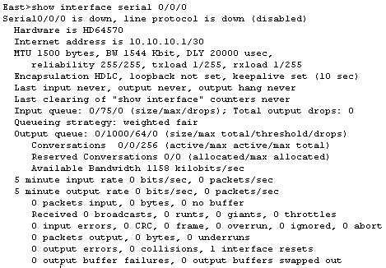

### Identify module expansion slots.

How many expansion slots are available to add additional modules to the **East** router?

Answer: 1 slot

Type your answers here.

Click **Switch2**.How many expansion slots are available?

Answer: 5 slots

## Select Correct Modules for Connectivity

### Determine which modules provide the required connectivity.

a. Click East and then click the Physical tab. On the left, beneath the Modules label, you see the available options to expand the capabilities of the router. Click each module. A picture and a description display at the bottom. Familiarize yourself with these options.

1)You need to connect PCs 1, 2, and 3 to the East router, but you do not have the necessary funds to purchase a new switch. Which module can you use to connect the three PCs to the East router?

Answer: HWIC-4ESW module

2)How many hosts can you connect to the router using this module?

Answer: 4 hosts

b.Click Switch2.

Which module can you insert to provide a Gigabit optical connection to Switch3?

Answer: PT-SWITCH-NM-1FGE

### Add the correct modules and power up devices.

a. 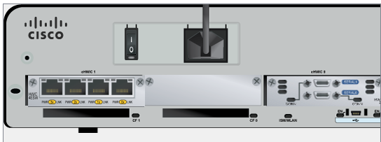

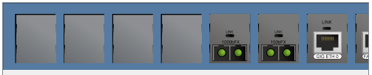

b.

Into which slot was it inserted?

Answer: GigabitEthernet5/1

## Connect Devices

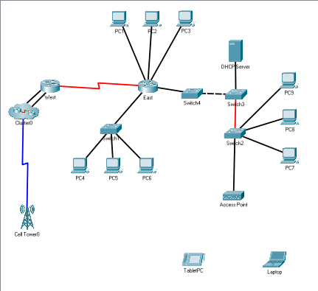

## Check Connectivity

### Check the interface status on East.

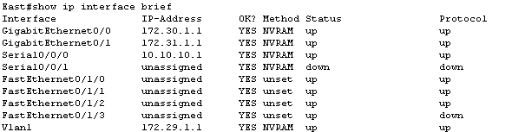 a.

### Connect wireless devices, Laptop and TabletPC.

a.

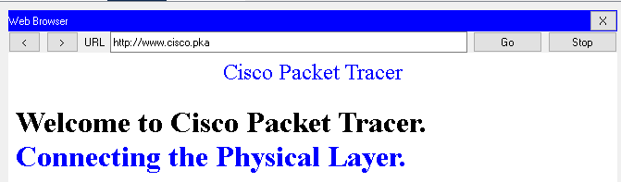 b.

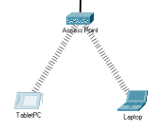

c.

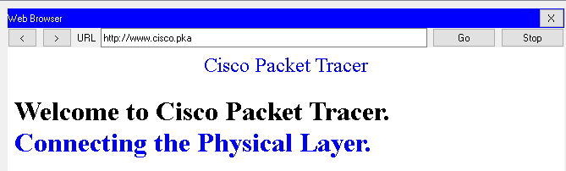 d.

### Change the access method of the TabletPC.

a.

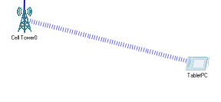

b.

 c.

### Check connectivity of the other PCs.

All of the PCs should have connectivity to the web site and each other. You will learn to use connectivity testing in many upcoming labs.

PC1:



PC2: